***Scope:***

By the data analysis and prediction of autism by machine of data taken after autism detection by screening we can get the detailed information of which children will get affect by autism.if a todders have behaviour which are in the 10 behaviours given in data we can easily detect whether a toddler have autism or not. And we can know which countries get more autism affected toddlers and what the reason is. it would more helpful to doctors and family members in prevention of autism in toddlers by taking necessary prevention steps.

***Introduction:***

Autism is a neurodevelopmental disorder. That means it affects both neurology and development. Because their neurology is different, autistic people experience the world differently their whole lives. That's why many people see being autistic as inseparable from who they are.

It's like comparing Windows computers and Apple computers. Yes, they both work differently, but it's not because of a processing error, it's because they're running a different operating system. It's the same with autistic people. Like the computers, both types of brains work, just differently.

As one autistic person put it, "Being autistic is like being left handed on the neurological level. Some things we can do readily or better than normal, some require a different tool to achieve the same result, and some will make us metaphorically smear ink on the paper." Autistic people have both strengths such as concentration, passion for special interests, attention to detail, and insight into patterns, and challenges such as social skills, communication, sensory problems, and trouble changing routines. In reality, though, many of the biggest challenges autistic people have don't come from their neurology. They come from the way society treats them as a result. Staring. Infantilizing. Shaming. Discriminating.

Demeaning. Bullying. It's also important to remember that not only is autism a spectrum, but there are also spectrums within the spectrum. So, if you've met one autistic person, you've met ONE autistic person.

**The most common disorders included:**

[Classic autism](http://www.nlm.nih.gov/medlineplus/ency/article/001526.htm):Deficits in communication and social interaction, along with restricted/repetitive behaviours, symptoms before age 3

[Asperger syndrome](http://www.nlm.nih.gov/medlineplus/ency/article/001549.htm)**:** Same main deficits as classic autism, but presents without language delays and requires fewer symptoms

[PDD-NOS](http://en.wikipedia.org/wiki/PDD-NOS) (Pervasive Developmental Disorder - Not Otherwise Specified): Doesn't meet criteria for the other pervasive developmental disorders, but still has deficits in communication, social interaction, and/or restricted, repetitive behaviors

Disorders considered rare/not always included in the 'umbrella' included:

[Childhood disintegrative disorder](http://www.nlm.nih.gov/medlineplus/ency/article/001535.htm): Child develops typically until age 3-4, then loses skills they had learned.

[Rett syndrome](http://www.ninds.nih.gov/disorders/rett/detail_rett.htm): Children develop typically at first, then regresses. Affects mainly girls and many autistic-like traits are present.

Recently, the organization that defines these diagnoses noticed the difference between disorders was subtle and many diagnoses were used interchangebly. As a result, it [integrated](http://www.dsm5.org/Documents/Autism%20Spectrum%20Disorder%20Fact%20Sheet.pdf) [all the pervasive developmental disorders into one name](http://www.dsm5.org/Documents/Autism%20Spectrum%20Disorder%20Fact%20Sheet.pdf)**:** autism spectrum disorder (ASD).

### WHAT IS AUTISM?

|  |  |
| --- | --- |
| **OLD GROUPING:**  Picture | **NEW GROUPING:**  Picture |

***Objective:***

The aim of our AUTISM DETECTION PROJECT is to Pre- Recognize Autistic Spectrum Disorder (ASD) if present in toddlers. This project can be helpful for diagnosing autism

Dataset:

The dataset has been taken from Kaggle.

The dataset is called ASD Tests (ASDtests.com) to screen autism in toddlers.

See the description file attached with the CSV data to know more about the variables and the class.

This data can be used for descriptive and predictive analyses such as classification, clustering, regression, etc. You may use it to estimate the predictive power of machine learning techniques in detecting autistic traits

***Analysis:***

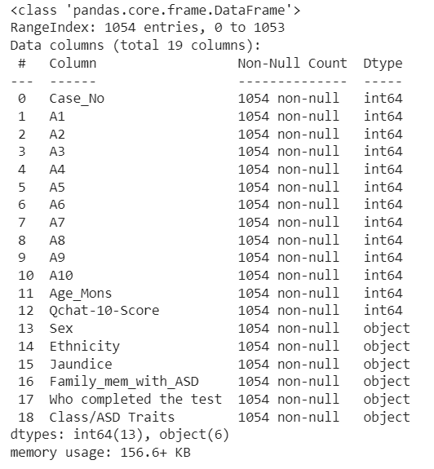 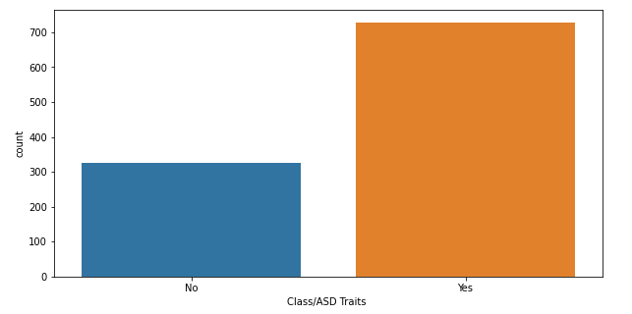

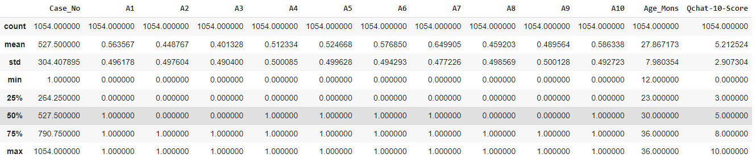

 

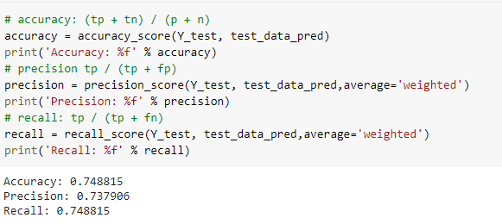 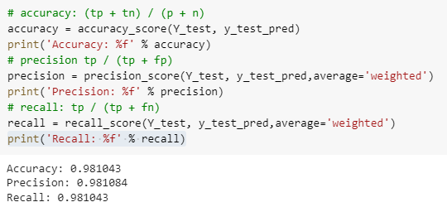



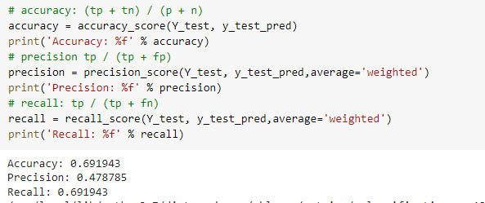

 

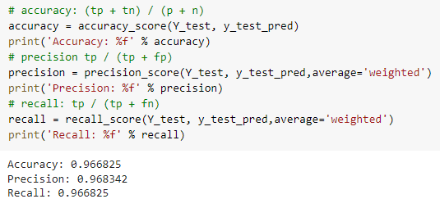 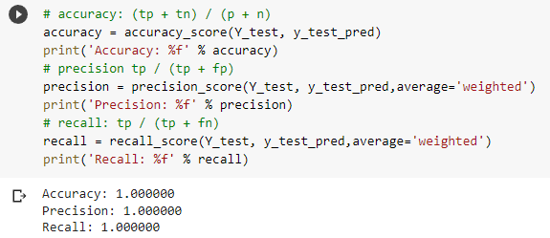

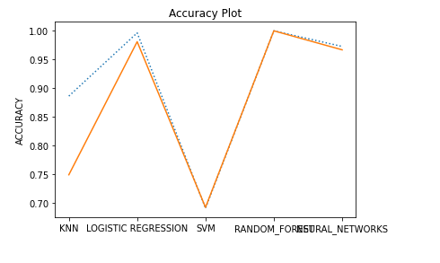

***LIBRARIES IMPORTED :***

1. **Pandas ->**

* Pandas Is a software library written for python programming, for data manipulation and analysis.
* It is widely used for data structures and operation for manipulating numerical tables.
* Reshaping and pivoting of data set, fancy indexing, label slicing column insertion and deletion etc.

1. **Matplotlib ->**

* Plotting library for python programming, provides and object-oriented application programming interface for embedding plots.
* Provides various forms for plotting a graph for numerical tables like line plot, histogram,

scatter plot contour plot etc.

1. **NumPy ->**

* NumPy adds support for large multidimensional array and matrices, along with a large collection of high-level mathematical functions to operate on these arrays.
* Core function of NumPy is “ndarray” for n-dimension array, data structure.

1. **Sklearn** ->

* Simple and efficient tools for predictive data analysis
* Accessible to everybody, and reusable in various contexts
* Built on NumPy, SciPy, and matplotlib
* Open source, commercially usable - BSD license

***References:***

<https://scikit-learn.org/stable/index.html>

<https://www.kaggle.com/datasets/fabdelja/autism-screening-for-toddlers>

***CONCLUSION:***

**So, we can conclude by saying that this project “Autism detection” is extremely useful for detecting autism at a very early age.** These findings suggest that a machine learning process is a reliable method for detection of autism outside of clinical settings. A variety of factors in the clinical analysis are discussed along with the solutions engineered into the algorithms. Final results are statistically limited and will benefit from future clinical studies to extend the sample size. The conclusion which we found is that which toddlers are likely to have autism by comparing various aspects such as age (in months), family members who have ASD, etc.